[Assignment 1](https://umassd.umassonline.net/webapps/assignment/uploadAssignment?content_id=_2547627_1&course_id=_38469_1&group_id=&mode=view)

**Exploratory Data Visualization Methods with Python**

**Upload Jupyter Notebook.**

**Material**

In the Colab provided below, a short introduction to "Seaborn" and "Altair" is provided.

Completion Required Challenges

You can find the challenges following the introduction to the "Seaborn" and "Altair" sections.

[Colab link](https://colab.research.google.com/drive/1DoNa824wPYe6PfSIpOr_LhntpVlng_sZ)

<https://colab.research.google.com/drive/1DoNa824wPYe6PfSIpOr_LhntpVlng_sZ?usp=sharing>

**Challenge 1:**

1.1 Use the data and provided code in the cells to generate the heatmap below using Seaborn. (15 points)

1.2 Regenerate the same visualization, but this time sort by "Under 5 years" and "5 to 9 years" in a descending format (10 points)

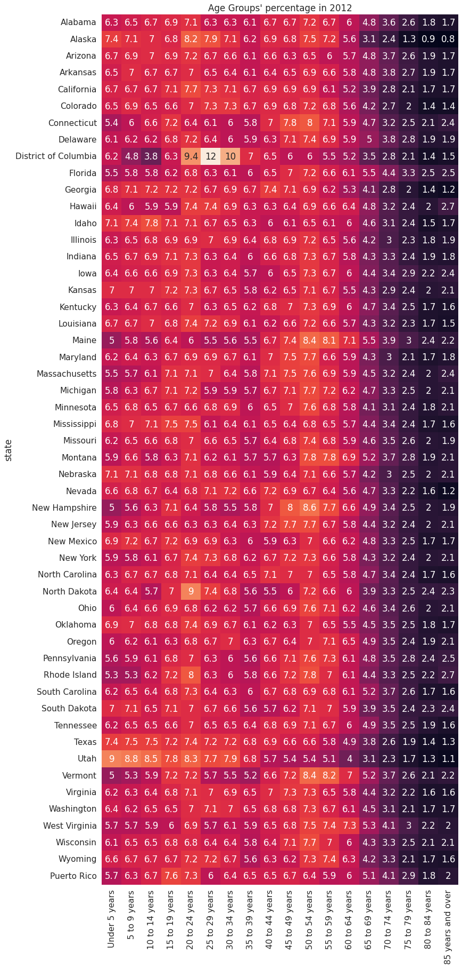

Challenge 2:

2 Come up with a function to plot the percentage of population groups for each year. See the figure below (25 points)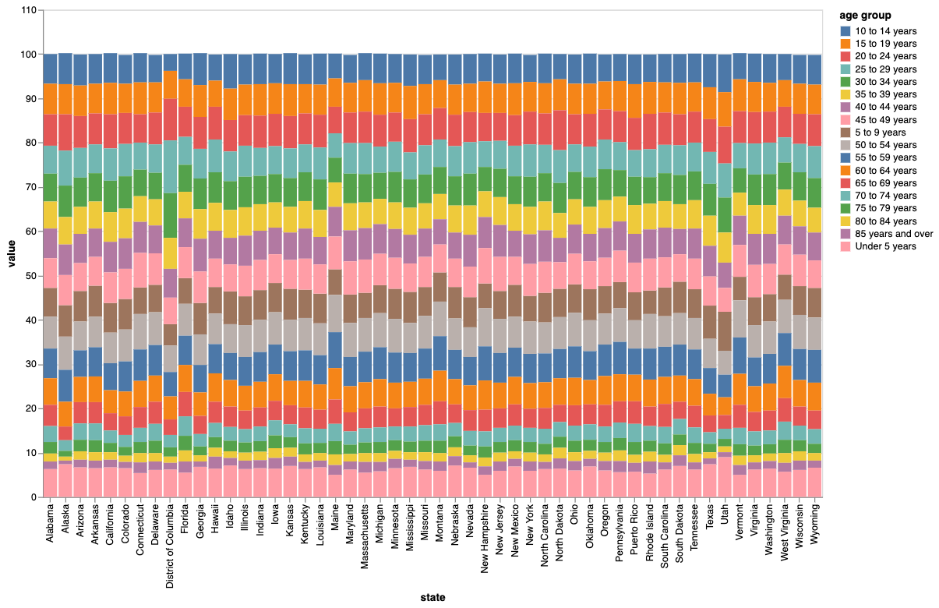

**Challenge 3: Seaborn Matplotlib**

3.1 The following population pyramid is incomplete and for all the states, make a function that can generate the same pyramid for 1 state only. (15 points)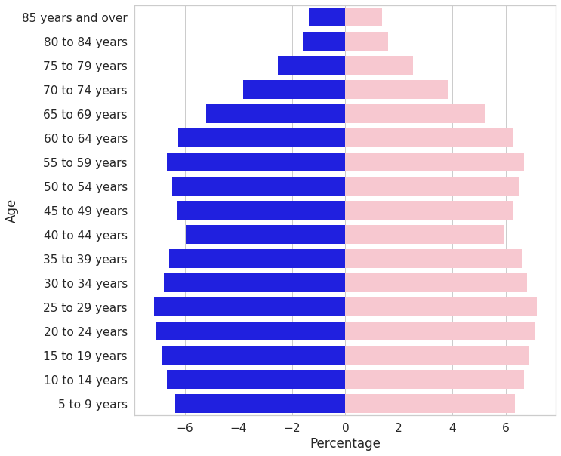

 3.2 After you come up with a function to generate the plot for 1 state, use the function and generate the plot for all states, similar to the figure below. (10 points)

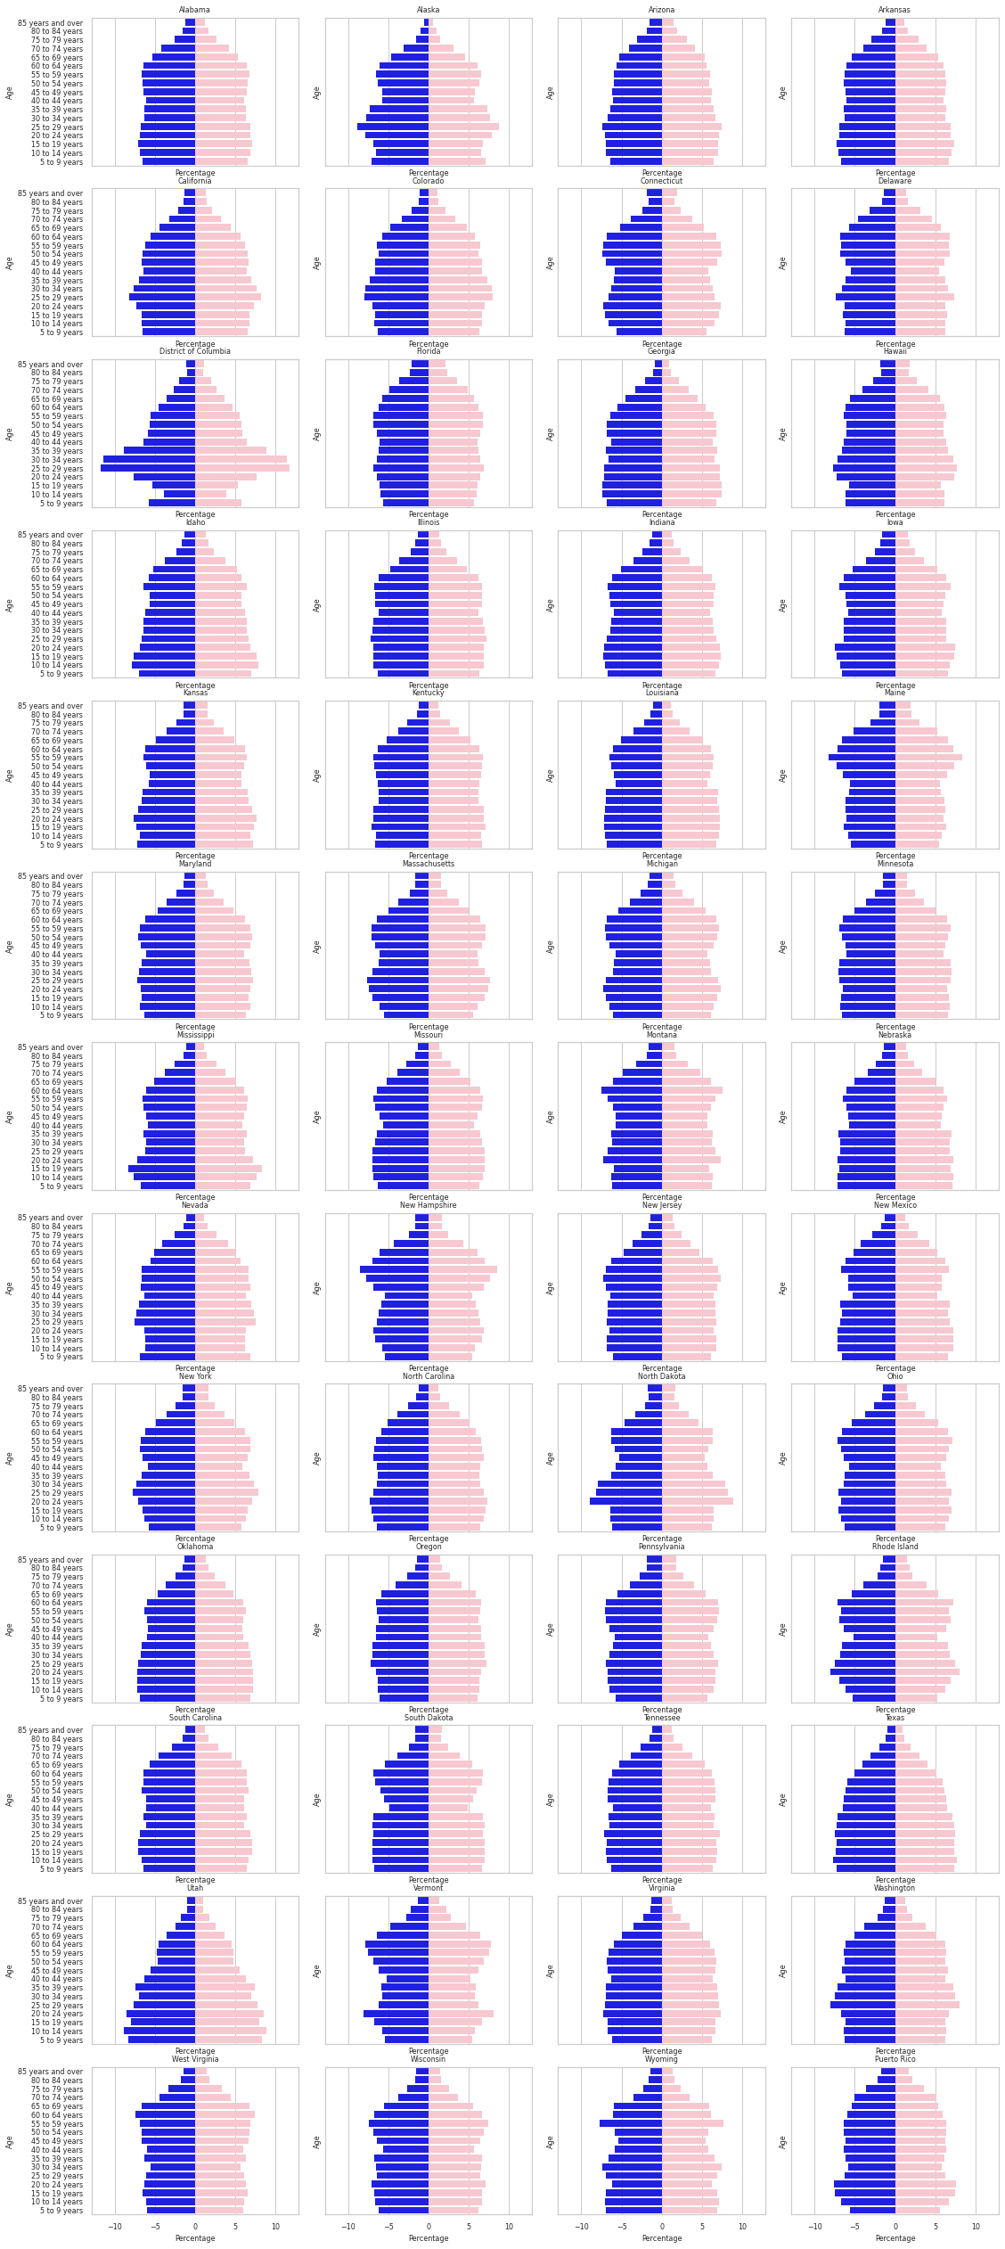

**Challenge 4: Seaborn Matplotlib**

Load the Spotify sample data from the following URI using Pandas dataframe.

<https://raw.githubusercontent.com/umassdgithub/Sample_Data/main/Spotify_Data.json>

Plot the figure below, where each line is representative of the music listening behavior of the population on each 3 months of the year. (25 points)

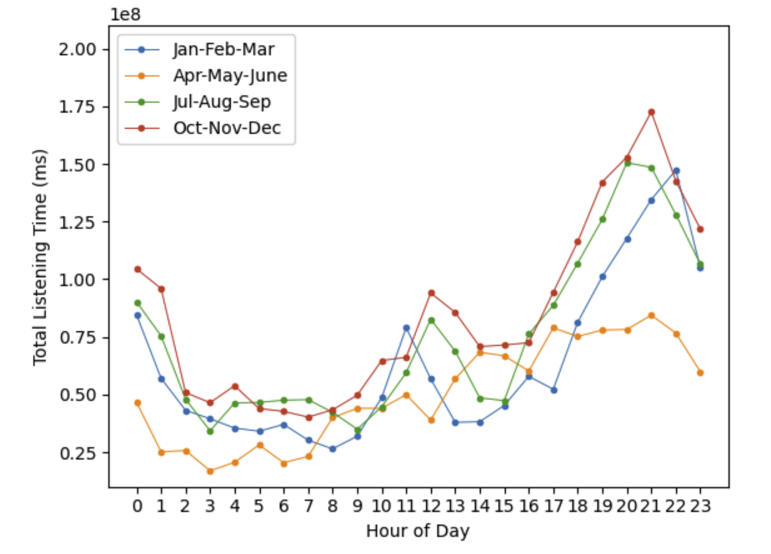

 Grading Factor: 1